REAL – TIME COMMUNICATION SYSTEMPOWERED BY AI FOR SPECIALLY ABLED



**IMAGE PREDICTION**



**UNSTRUCTURED DATA**



**IMAGE**

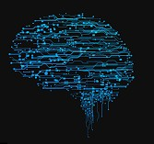**NEURAL NETWORK**



**FLASK UI**



**MODELS**



**EVALUATE DATA**



**STRUCTURED DATA**



**OUTPUT**



**SPEECH**



**USER**